**REST API Automation Tool**

**By**

**Maheswar Nandakumar | 469 394 7346 |lostwaltkins@gmail.com**

**About the tool**

This tool allows users to automate REST API calls (Post and Get). This was implemented using JAVA’s Jersey framework. The tool is comprised of

1. **Rest.jar File**

The jar will read values from api.property file and invokes the API’s and save the response.

1. **api.property File**

The property file contains details such as the Rest URL, Path where input files are located, the Header details (for PostStatic and Get methods) and the method.

Example of api.property File used for PostStatic

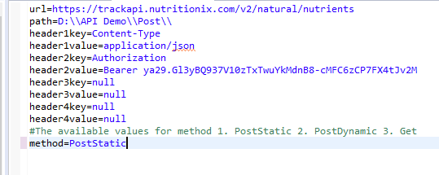

**Methods Supported**

1. **Get**

This method is used to automate invocation of GET calls and saves the response based on values read from api.properties file.

The api.properties file will have only Path, Headers and Method. REST Url’s will be read from input file.

As Input, this method needs a file which has the list of REST URL to be invoked. Example below.

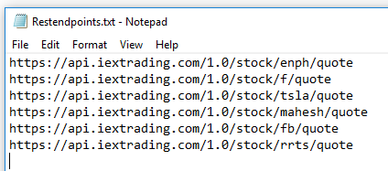

1. **PostStatic**

This method is used to automate invocation of POST calls (when REST URL and Headers remains the same. Only the Payload changes). The response get saved to Out folder based on values read from api.properties file.

As Input, this method needs a file/files which has the Payload, Test Case Name & Test Case ID (Optional). Example below.

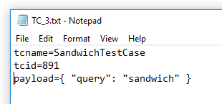

1. **PostDynamic**

This method is used to automate invocation of POST calls (when REST URL, Headers and the Payload are different). The response get saved to Out folder based on values read from api.properties file.

The api.properties file will have only Path and Method. Rest all will be read from input file/files.

As Input, this method needs a file/files which has the REST Url, Headers, Payload, Test Case Name &Test Case ID(Optional). Example below.

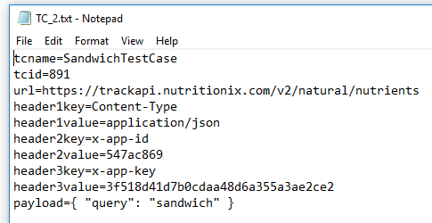

**Supported Error Handling Techniques**

1. **Identify if the URL is syntactically incorrect**
2. **Identify if the rest URL is not reachable/up**
3. **Handle error responses other than 200**

**Advantages**

1. **Hundreds of API’s can be tested, and the response could be saved in just few seconds.**
2. **Retrieve the list of Failed/Success API’s in separate CSV files.**